**Q.1 Program to find the lowest number out of two numbers**

num1 = float(input("Enter the first number: "))

num2 = float(input("Enter the second number: "))

if num1 < num2:

print(f"The lowest number is: {num1}")

else:

print(f"The lowest number is: {num2}")

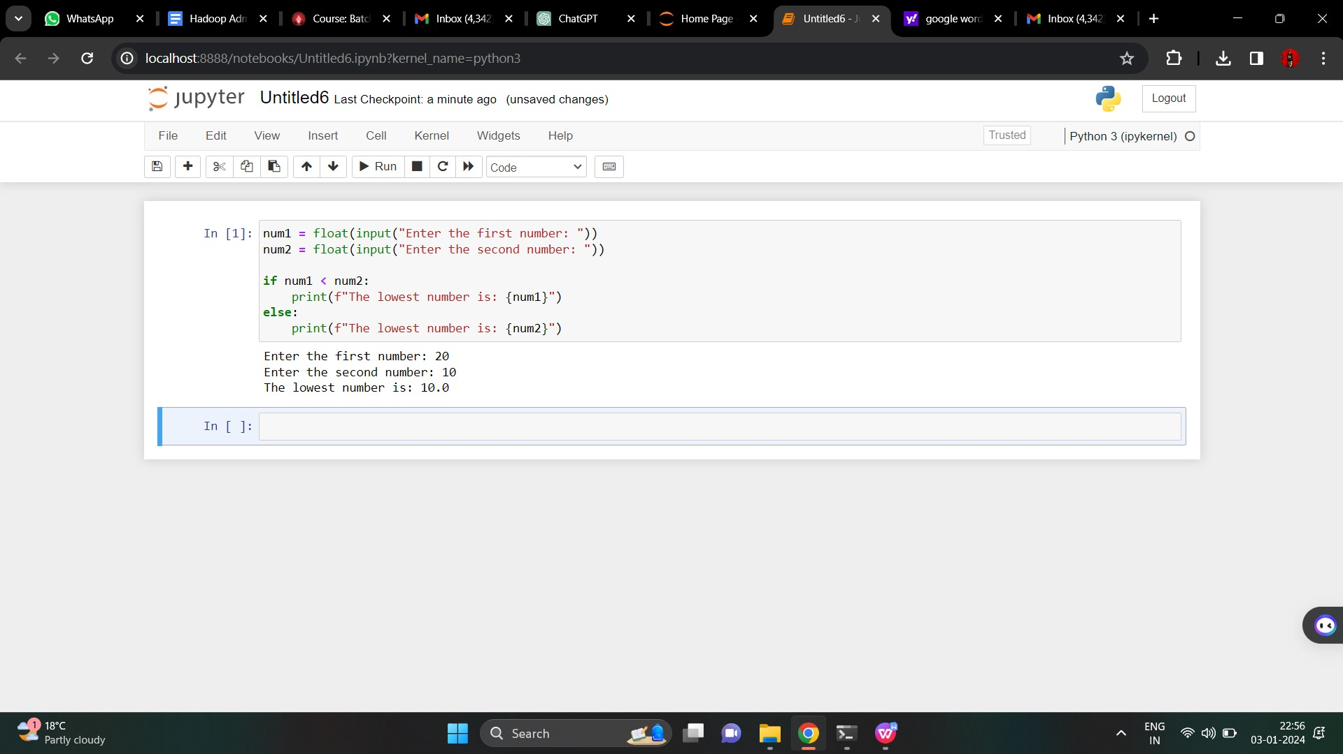

**Q.2 Program to check whether a number is divisible by 2 and 3 both**

number = int(input("Enter a number: "))

if number % 2 == 0 and number % 3 == 0:

print(f"{number} is divisible by both 2 and 3.")

else:

print(f"{number} is not divisible by both 2 and 3.")

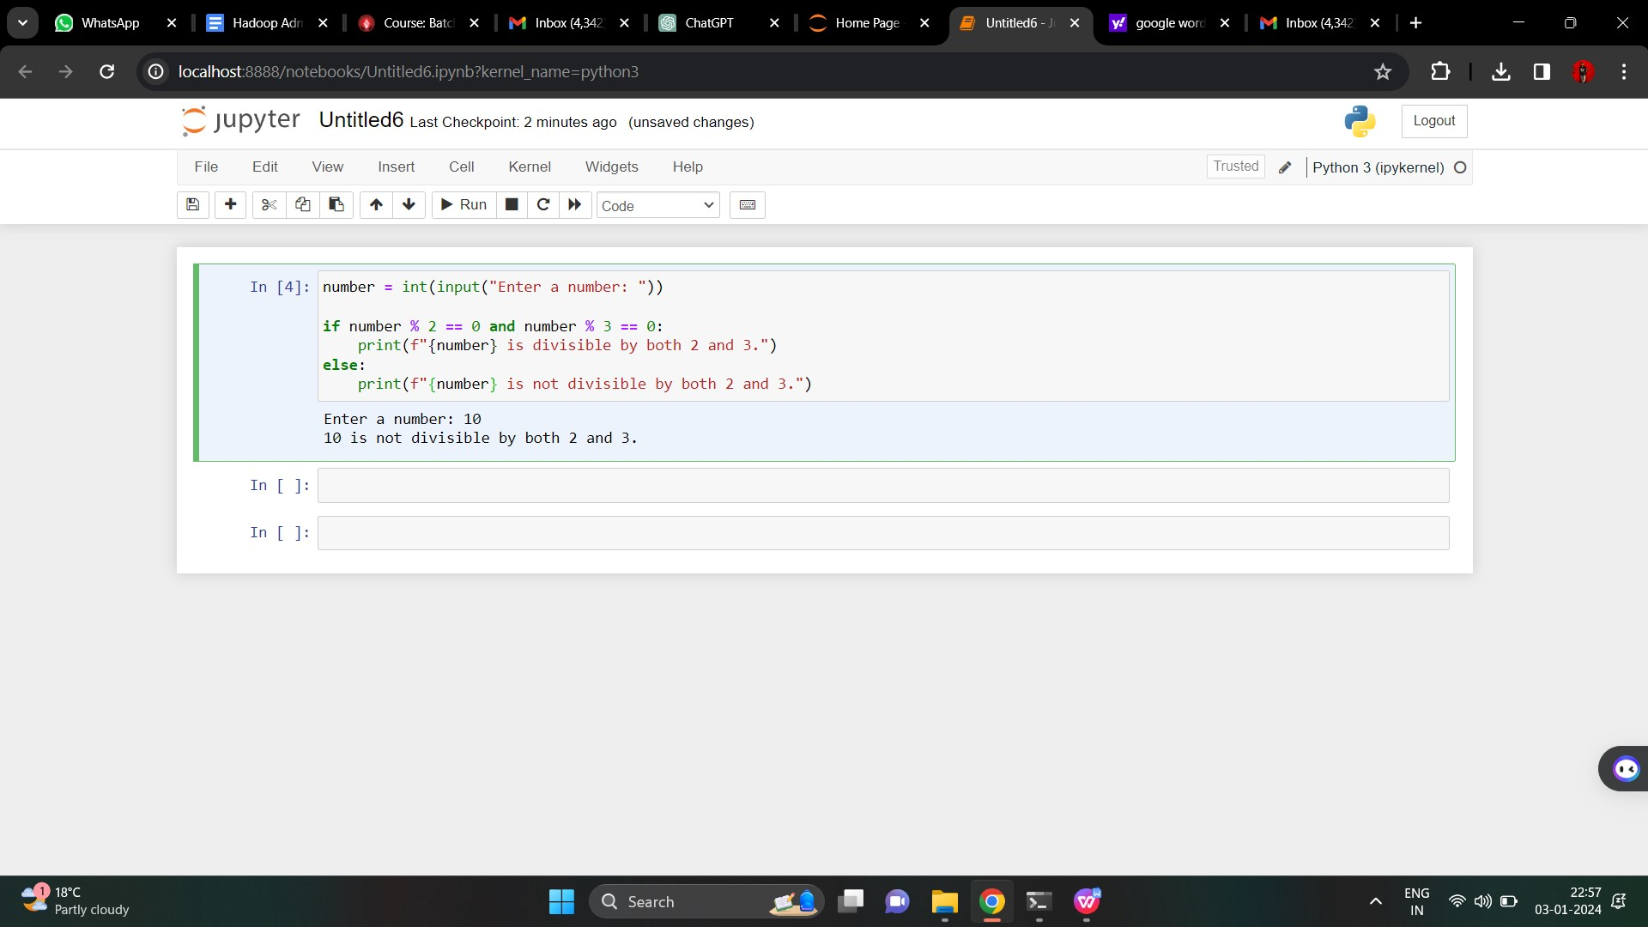

**Q.3 Program to find the oldest person among four**

age1 = int(input("Enter age of person 1: "))

age2 = int(input("Enter age of person 2: "))

age3 = int(input("Enter age of person 3: "))

age4 = int(input("Enter age of person 4: "))

oldest_age = max(age1, age2, age3, age4)

print(f"The oldest person is {oldest_age} years old.")

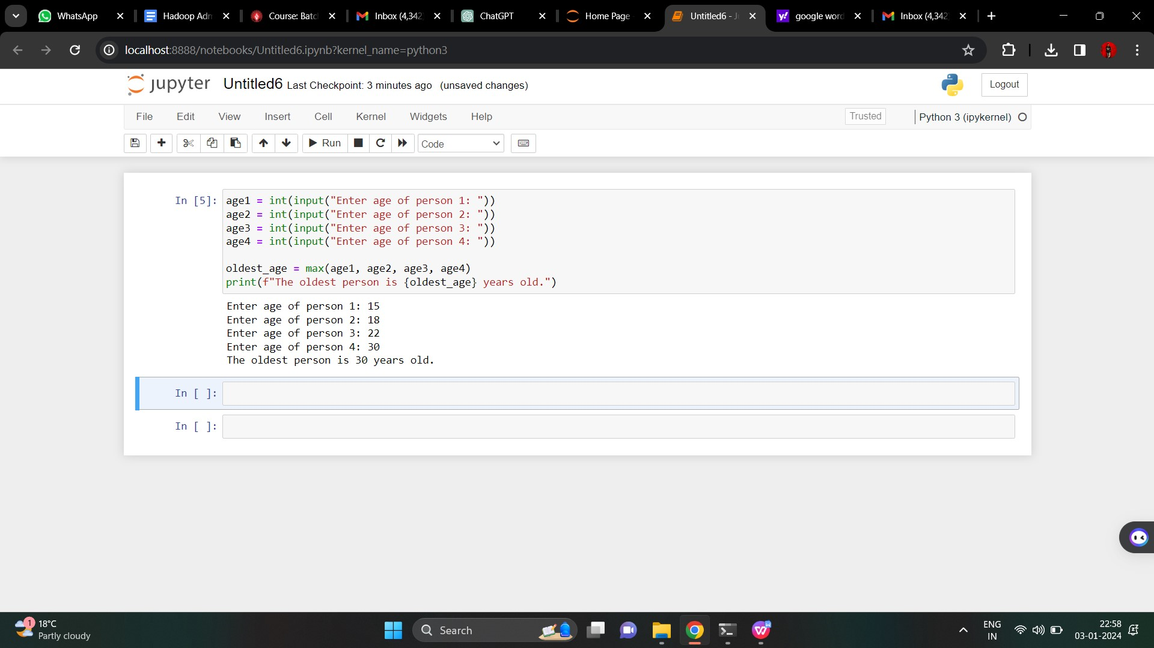

**Q.4 Program to check whether a number is prime or not**

number = int(input("Enter a number: "))

if number > 1:

for i in range(2, int(number/2) + 1):

if (number % i) == 0:

print(f"{number} is not a prime number.")

break

else:

print(f"{number} is a prime number.")

else:

print(f"{number} is not a prime number.")

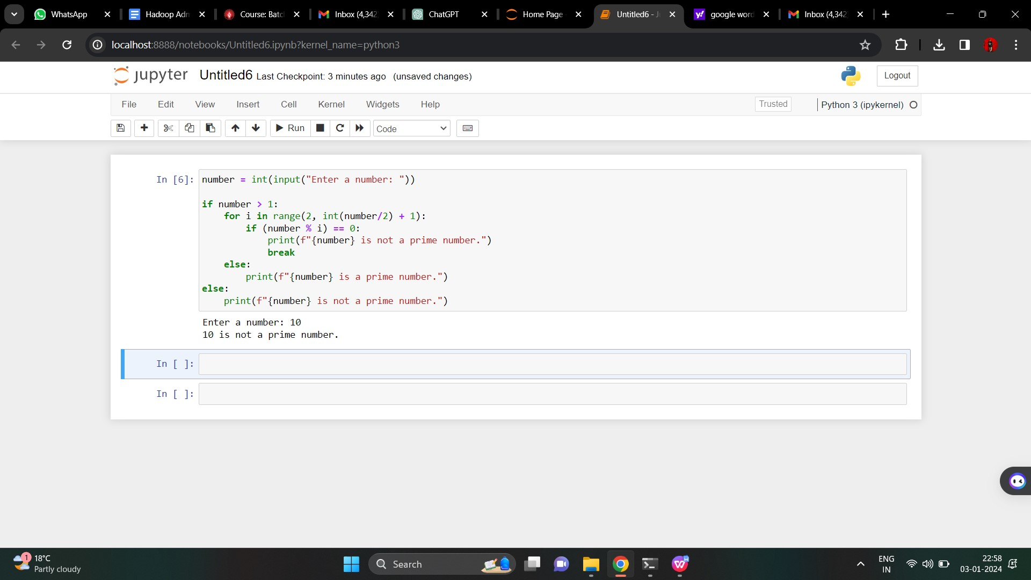

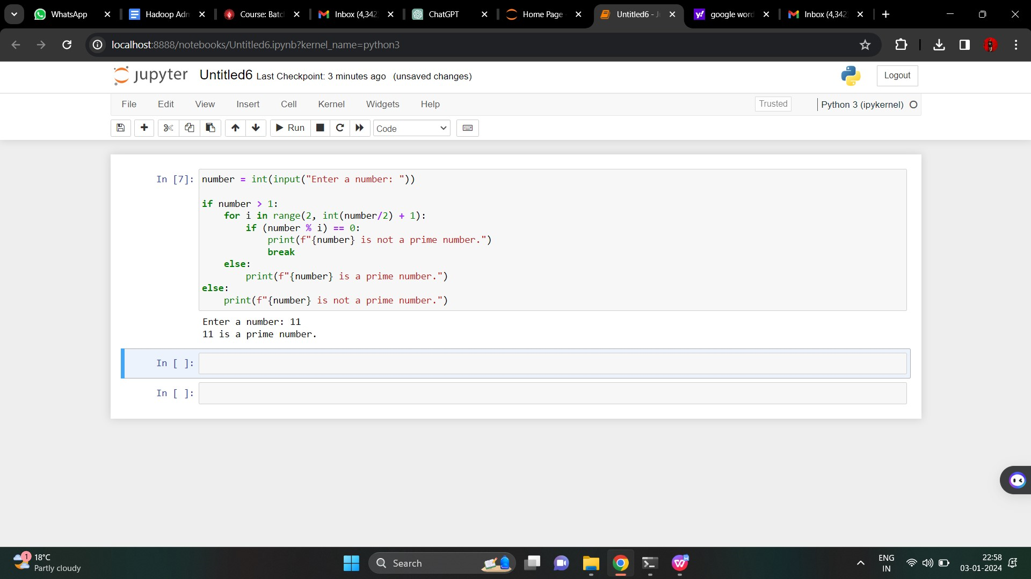

**Q.5 Program to check whether a character is a vowel or not**

character = input("Enter a character: ").lower()

if character in ['a', 'e', 'i', 'o', 'u']:

print(f"{character} is a vowel.")

else:

print(f"{character} is not a vowel.")

